1. **­Purpose**

To describe the procedure for validating or revalidating alternate USP impurity limit test methods using the Prodigy High Dispersion Simultaneous ICP Spectrometer with axial and halogen options, as per USP General Chapter <1225>.

1. **Scope**

This validation protocol applies to methods developed for the Prodigy High Dispersion Simultaneous ICP Spectrometer with axial and halogen options as alternatives to standard USP impurity limit tests.

1. **Responsibility**

QA Lab personnel are responsible for validation and revalidation of ICP methods.

1. **Safety Considerations**

Safety Goggles, Chemical Resistant Gloves, and Lab Coat should be worn.

Safety is a condition of employment. Employees are not authorized to work in an unsafe manner and are prohibited from harming the environment of the facility or community.

1. **Procedure**
   1. Once a satisfactory ICP method has been developed, prepare a set of 18 validation spike samples. Each should be prepared using Giles magnesium sulfate heptahydrate from the same lot, and spiked with all impurities covered in the current USP monograph for magnesium sulfate heptahydrate, as follows.
   2. Prepare three unspiked magnesium sulfate heptahydrate samples for analysis according to the method being validated.
   3. Prepare three samples spiked with 0.25 times the impurity limits specified in the USP monograph for magnesium sulfate heptahydrate.
   4. Prepare three samples spiked with 0.50 times the impurity limits specified in the USP monograph for magnesium sulfate heptahydrate.
   5. Prepare three samples spiked with 1.0 times the impurity limits specified in the USP monograph for magnesium sulfate heptahydrate.
   6. Prepare three samples spiked with 1.5 times the impurity limits specified in the USP monograph for magnesium sulfate heptahydrate.
   7. Prepare three samples spiked with 2.0 times the impurity limits specified in the USP monograph for magnesium sulfate heptahydrate.
   8. Using the ICP method being validated, analyze each of these 18 samples for all impurities in the ICP method.
   9. Print out the data generated from the analyses and place into the validation notebook along with the ICP method, and a description of the steps performed in the completion of this validation protocol.
   10. Average the unspiked concentrations for each impurity.
   11. For each impurity, determine the recovered concentration for each sample by subtracting the average unspiked concentration from each sample’s spiked concentration.
   12. For each impurity calculate a percent recovery for each sample.
   13. Calculate an average percent recovery and standard deviation for each impurity.
   14. For each impurity calculate a relative standard deviation expressed as a percentage (% RSD) for the measured values of each set of three spiked samples.
   15. Average the % RSD for all sets of three spiked samples for each impurity. This will be used to indicate precision.
   16. For each impurity, graph the relationship between each recovered concentration and actual concentration.
   17. Calculate the slope of this relationship by generating a linear regression line and equation, with a Y intercept set to zero, along with a coefficient of determination (R2).
   18. Calculate the standard error in the slope for each impurity.
   19. Calculate the degrees of freedom for each impurity’s data set.
   20. Using the slope, standard error in the slope, and the degrees of freedom, calculate 95% confidence intervals and confidence limits for the slope of each impurity’s recovered concentration vs. actual concentration equation. These will be used to indicate accuracy.
   21. Verify that the method is suitable for testing for impurities included in the method that are not part of the validation.
2. **Validation Criterion**
   1. Accuracy—For each impurity included in the validation, the accuracy is evaluated using the 95% confidence limits of the slope of the recovered concentration vs. actual concentration equation. The accuracy is considered acceptable if both confidence limits are within ±20% of 1.0 (in other words: the confidence interval for the slope is contained within a 20% interval around 1.0).
   2. Precision— For each impurity included in the validation, the precision is evaluated using the average % RSD. The precision is considered acceptable if the average % RSD is less than or equal to 5%.
   3. Specificity— For each impurity included in the validation, the specificity is evaluated using the percent recoveries for each sample, and the average % RSD for each impurity. Because all USP impurities are present in the spiked sample, recoveries between 80% and 120% on all spiked samples and an average % RSD less than or equal to 5%, demonstrate that each impurity is determined with appropriate accuracy and precision; therefore showing acceptable specificity.
   4. Detection Limit—Determination of the actual detection limits is not necessary. Rather, the detection limit for each impurity included in the validation is evaluated to be sufficiently low if the requirements for accuracy are met and the percent recoveries for samples spiked with 0.25 times the impurity limit are between 80% and 120%. This shows that the detection limit is below 0.25 times the impurity limit.
   5. Linearity— For each impurity included in the validation, linearity is evaluated using the coefficient of determination (R2) for the recovered concentration vs. actual concentration equation. The linearity is considered acceptable if the R2 value is greater than 0.950.
   6. Range—For each impurity included in the validation, the range is the interval between 0.25 times the impurity limit and 2.0 times the impurity limit (including these levels), if all samples tested within this range show a suitable level of accuracy, precision, and linearity, as determined above.
3. **Reference Documents**

N/A

1. **Approvals**

Signing below indicates agreement that the protocol is ready for execution of the USP ICP Method Validation Protocol for the Prodigy High Dispersion Simultaneous ICP Spectrometer with axial and halogen options.

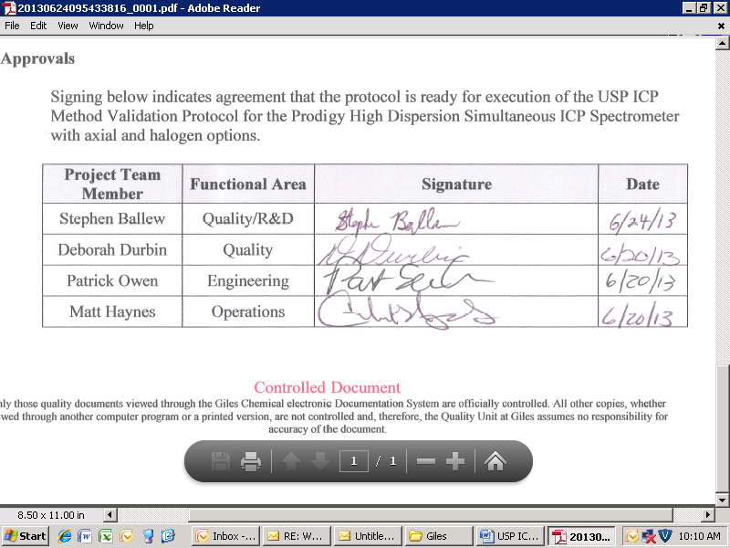

|  |  |  |  |
| --- | --- | --- | --- |
| **Project Team Member** | **Functional Area** | **Signature** | **Date** |
| Stephen Ballew | Quality/R&D |  |  |
| Deborah Durbin | Quality |  |  |
| Patrick Owen | Engineering |  |  |
| Matt Haynes | Operations |  |  |